Aviel Resnick

AP COMP SCI A

12/19/2017

Problem Set 15.4:

Page 270

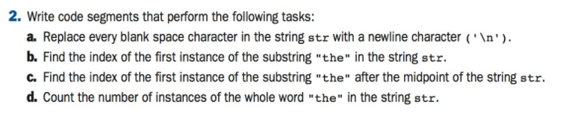

Problem 2:

1. str = str.replace(“ ”, “\n”);
2. return(str.indexOf(“the”));
3. return(str.indexOf(“the”, str.length() / 2));
4. while (index != -1) {  
    index++;  
    index = str.indexOf(“the”, index);  
    instances++;  
   }

return (instances);

Page 279

Problem 1-8:

1. List the three logical operators.
   1. The three logical operators are and (&&), or (||) , and not (!)
2. Construct a truth table for the expression P OR NOT Q.

|  |  |  |
| --- | --- | --- |
| P | Q | P OR NOT Q |
| True | True | True |
| True | False | True |
| False | True | False |
| False | False | True |

1. Suppose P is true and Q is false. What is the value of the expression P AND NOT Q?
   1. The value is True, as both P is True, and Not Q is True.
2. Write an if statement that displays whether or not a given number is between a lower bound min and an upper bound max, inclusive. Use a logical operator in the condition.
   1. if ( n >= min && n <= max ) {
      1. // N is in between min and max
   2. }
3. Rewrite the if statement in Question 4 to use a nested if statement.
   1. if (n >= min) {
      1. if (n <= max) {
         1. // N is in between min and max
      2. }
   2. }
4. Write a nested loop that displays a 10-by-10 square of asterisks.
   1. for (int i = 0; i < 10; i++) {
      1. for (int x = 0; x < 10; x++){
         1. System.out.print(“”);
      2. }
      3. System.out.println(“”);
   2. }
5. Give an example of an assertion and show how it can be checked with Java’s assert statement.
   1. An example of an input assertion is: x must be an int, greater than 1
   2. asset x > 1; // asserts the above condition
6. Explain the role that variant and invariant assertions play in showing that a loop is correct.
   1. Variant and invariant assertions check whether a variable has changed or not changed, respectively. This is important when checking whether a loop changed a desired variable (or didn’t).